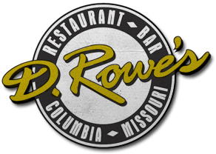
CDCTA AWARDS BANQUET
January 12, 2020 from 12:00 PM to 3:00 PM

Join us Sunday, Jan. 12th 2020 for fun, food and celebration.
Located at D. Rowe’s Restaurant
1005 Club Village Drive, Columbia, 56203

Members, friends and significant others are welcome.
We will have appetizers and off the menu ordering, 2019 highlights, 2020 club goals, and of course 2019 Year End Awards!

To Reserve your spot, please send $25 per person attending to Ali Aitken

DUE BY SATURDAY, JANUARY 5th

Please Detach and mail RSVP with check (payable to CDCTA) to:
Ali Aitken
2608 Spanish Bay Dr., Columbia, MO 65202

______ Persons attending @ $25 each = __________ enclosed.

Name(s): ___________________________________________________________

